**Project Design Phase-II**

**Data Flow Diagram & User Stories**

|  |  |
| --- | --- |
| Date | 03 October 2022 |
| Team ID | PNT2022TMIDxxxxxx |
| Project Name | Project - xxx |
| Maximum Marks | 4 Marks |

**Data Flow Diagrams:**

A Data Flow Diagram (DFD) is a traditional visual representation of the information flows within a system. A neat and clear DFD can depict the right amount of the system requirement graphically. It shows how data enters and leaves the system, what changes the information, and where data is stored.

Example: DFD Level 0 (Industry Standard)

**Example:** [**(Simplified)**](https://developer.ibm.com/patterns/visualize-unstructured-text/)

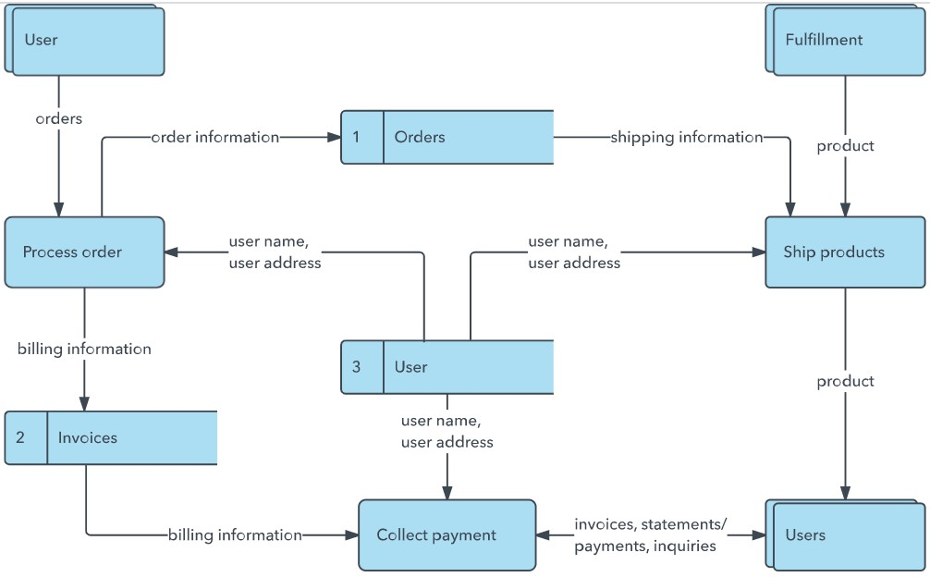

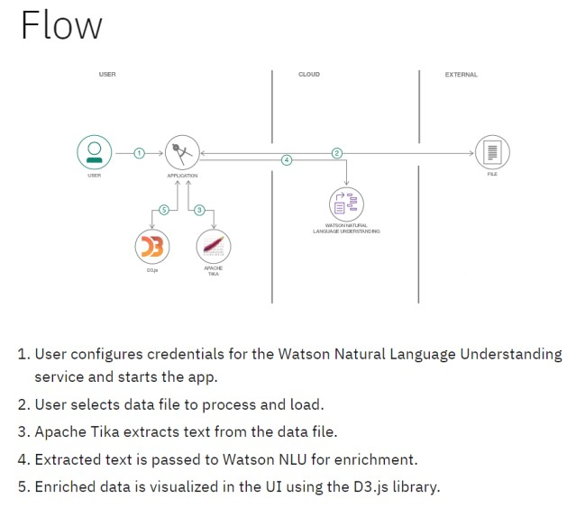

**User Stories**

Use the below template to list all the user stories for the product.

|  |  |  |  |  |  |  |
| --- | --- | --- | --- | --- | --- | --- |
| **User Type** | **Functional**  **Requirement (Epic)** | **User Story**  **Number** | **User Story / Task** | **Acceptance criteria** | **Priority** | **Release** |
| Customer  (Mobile user) | Registration | USN-1 | As a user, I can register for the application by entering my email, password, and confirming my password. | I can access my account / dashboard | High | Sprint-1 |
|  |  | USN-2 | As a user, I will receive confirmation email once I have registered for the application | I can receive confirmation email & click confirm | High | Sprint-1 |
|  |  | USN-3 | As a user, I can register for the application through Facebook | I can register & access the dashboard with Facebook Login | Low | Sprint-2 |
|  |  | USN-4 | As a user, I can register for the application through Gmail |  | Medium | Sprint-1 |
|  | Login | USN-5 | As a user, I can log into the application by entering email & password |  | High | Sprint-1 |
|  | Dashboard |  |  |  |  |  |
| Customer (Web user) |  |  |  |  |  |  |
| Customer Care Executive |  |  |  |  |  |  |
| Administrator |  |  |  |  |  |  |
|  |  |  |  |  |  |  |
|  |  |  |  |  |  |  |
|  |  |  |  |  |  |  |

## DATAFLOW DIAGRAM

**User Stories**

Use the below template to list all the user stories for the product.

|  |  |  |  |  |  |  |
| --- | --- | --- | --- | --- | --- | --- |
| **User Type** | **Functional**  **Requirement (Epic)** | **User Story**  **Number** | **User Story / Task** | **Acceptance criteria** | **Priority** | **Release** |
| Healthcare Professional (PC) | Accessing data | USN-1 | As a user, I can access the CTG dataset by logging in with my credentials. | I can log in using provided credentials and access the CTG dataset dashboard. | High | Sprint-1 |
|  |  | USN-2 | As a user, I will receive confirmation email once I have registered for the application | I can receive confirmation email & click confirm | High | Sprint-1 |
|  |  | USN-3 | As a user, I can filter and search the CTG dataset based on specific features or fetal health classifications. | I can use filters to refine dataset view and search for specific records. | Medium | Sprint-2 |
|  |  | USN-4 | As a user, I can register for the application through Work mail |  | High | Sprint-1 |
|  | Login | USN-5 | As a user, I can log into the application by entering email & password |  | High | Sprint-1 |
| Customer Care Executive | Support and Assistance | USN-6 | As a customer care executive, I can view summary reports of the CTG dataset. | I can access summary reports displaying overall statistics and trends from the dataset. | High | Sprint-2 |
|  |  | USN-7 | As a customer care executive, I can generate custom reports based on specific criteria. | I can create reports with selected parameters (e.g., time range, health classifications) | Medium | Sprint-3 |
|  |  | USN-8 | As a customer care executive, I can export reports for sharing with healthcare professionals. | I can export reports in a format suitable for sharing (e.g., PDF, Excel). | High | Sprint-3 |
| Administrator |  | USN-9 | As an administrator, I can manage user access levels and permissions. | I can assign roles and access permissions to users (e.g., read-only, admin). | High | Sprint-4 |
|  |  | USN-10 | As an administrator, I can monitor system performance and data integrity. | I can access logs and performance metrics for system monitoring. | Medium | Sprint-4 |
|  |  | USN-11 | As an administrator, I can perform system backups and data maintenance tasks | I can schedule and execute backups and data maintenance routines. | High | Sprint-4 |